C64 Keyboard Connector PCB Rev. 0
Module Description

Introduction
The purpose of this PCB is to connect the C64 Keyboard (Project. No. 223 or 225) to the C64/Ultimate64 Keyboard Connector.
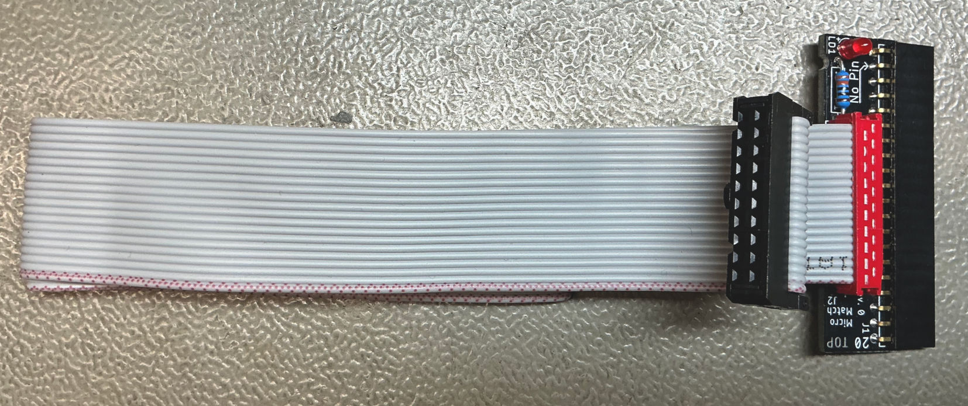
Figure 1: C64 Keyboard Connector PCB with ribbon cable
The connector for the ribbon cable is a MicroMatch series connector (red). They are low profile, so the cable does not collide with the side of the case when connected to a C64 long board. The C64 Keyboard has a 2x10p pin header, so the ribbon cable has two different types of connectors attached.

Dimensions
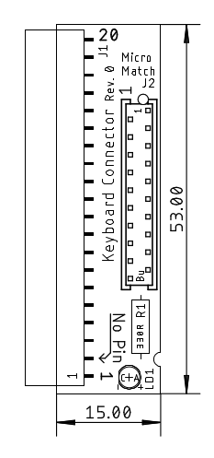
Figure 2: Dimensions of the PCB

Pinouts

J1 – Connector to mainboard
2.54mm pitch socket, 90°
Pin | Signal
1 | GND
2 | No pin
3 | /RESTORE
4 | +5V
5 | ROW3
6 | ROW6
7 | ROW5
8 | ROW4
9 | ROW7
10 | ROW2
11 | ROW1
12 | ROW0
13 | COL0
14 | COL6
15 | COL5
16 | COL4
17 | COL3
18 | COL2
19 | COL1
20 | COL7

J2 – Ribbon Cable Connector
MicroMatch Socket, 20 pins
Pin | Signal
1 | GND
2 | No pin
3 | /RESTORE
4 | +5V
5 | ROW3
6 | ROW6
7 | ROW5
8 | ROW4
9 | ROW7
10 | ROW2
11 | ROW1
12 | ROW0
13 | COL0
14 | COL6
15 | COL5
16 | COL4
17 | COL3
18 | COL2
19 | COL1
20 | COL7

Cable
The cable is a 20p ribbon cable of 45cm with one side attached to a 2x10p IDC socket with strain relief on the keyboard side and a 20 pin MicroMatch connector (male) on the side of this PCB. The cable is shown in drawing number 224-3-01-00.
Both connector types are easy to attach, since they are both IDC (insulation-displacement contact), so you only require a vice to compress them, after the ribbon cable is positioned.
The length of 45cm is the longest possible, calculated for a C64 longboard (the keyboard connector is top left on the mainboard). For short boards, 30cm is long enough

Revision History

Rev. 0
- Working prototype

